Employability Skills Assignment

Employability skills are those personal skills, behaviours and attitudes seen as essential for success both personally and in the work world.

Below are the Employability Skills employers are looking for as identified by The Conference Board of Canada.

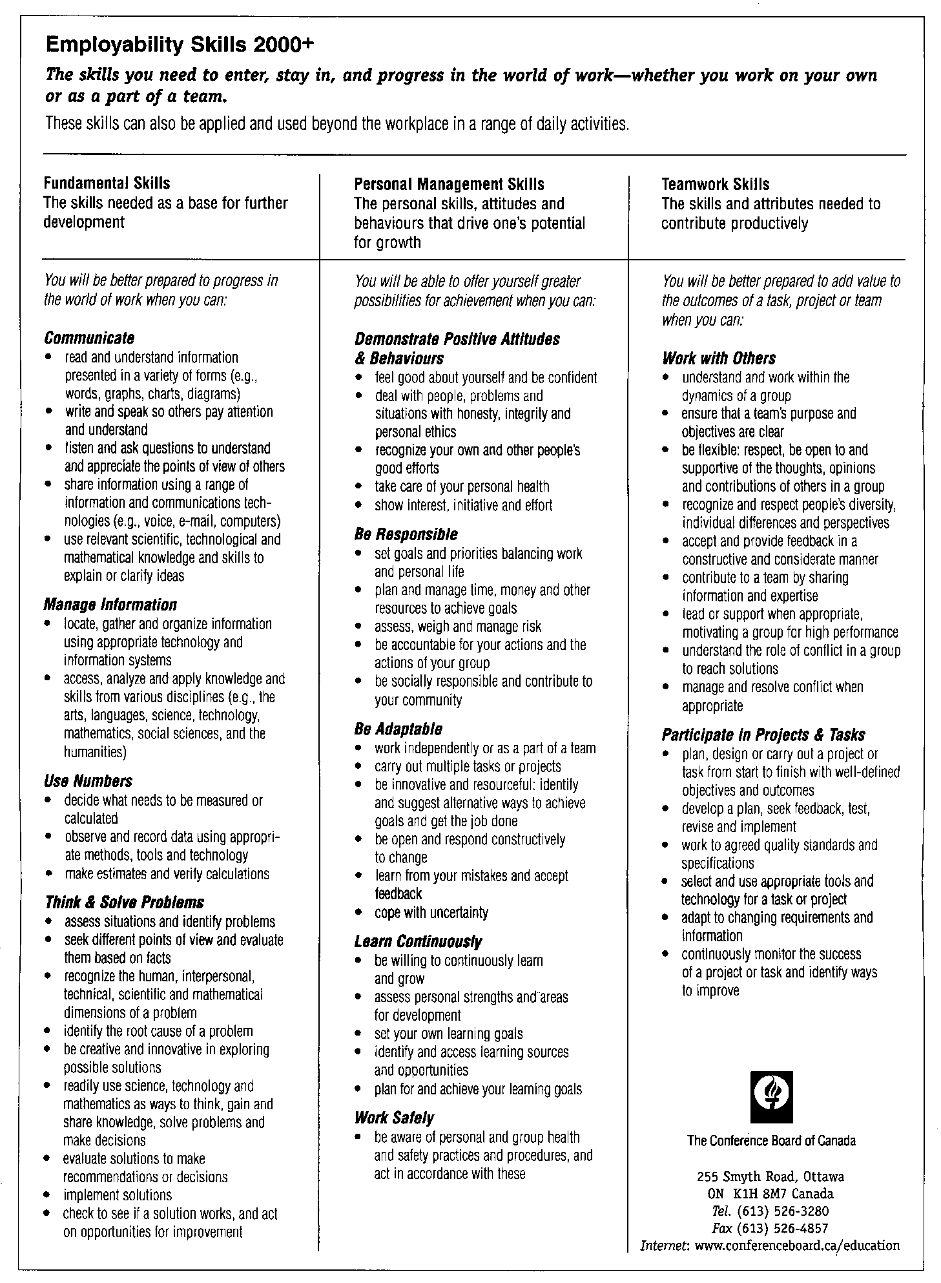

This document can also be found at: https://www.edu.gov.mb.ca/k12/cur/cardev/gr12_found/blms/blm18.pdf

1. From the Employability Skills Chart, identify and list some skills you possess
now:

- _____________________________________________________

- _____________________________________________________

- _____________________________________________________

- _____________________________________________________

- _____________________________________________________

There are three broad categories identified for Employability Skills; Fundamental Skills, Personal Management Skills, and Teamwork Skills. Identify one skill for each category that you possess and provide evidence of what you did and how you demonstrated that skill.

Example: Category – Teamwork Skills
Skill – contribute to a team by sharing information and expertise
Evidence - I shared my knowledge of climate change with my group in Socials 10

Category: Fundamental Skills

Skill: __________________________________________________________________

__________________________________________________________________

Evidence: __________________________________________________________________

__________________________________________________________________

Category: Personal Management Skills

Skill: __________________________________________________________________

__________________________________________________________________

Evidence: __________________________________________________________________

__________________________________________________________________

Category: Teamwork Skills

Skill: __________________________________________________________________

__________________________________________________________________

Evidence: __________________________________________________________________

__________________________________________________________________

