**Goal Setting Assignment**

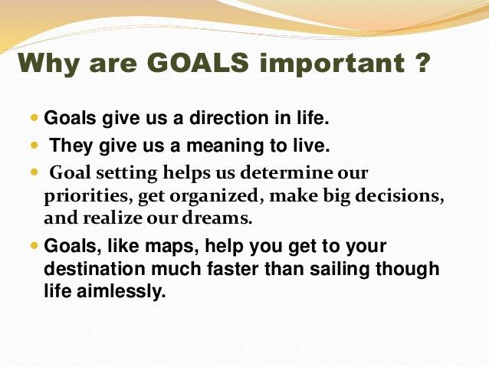

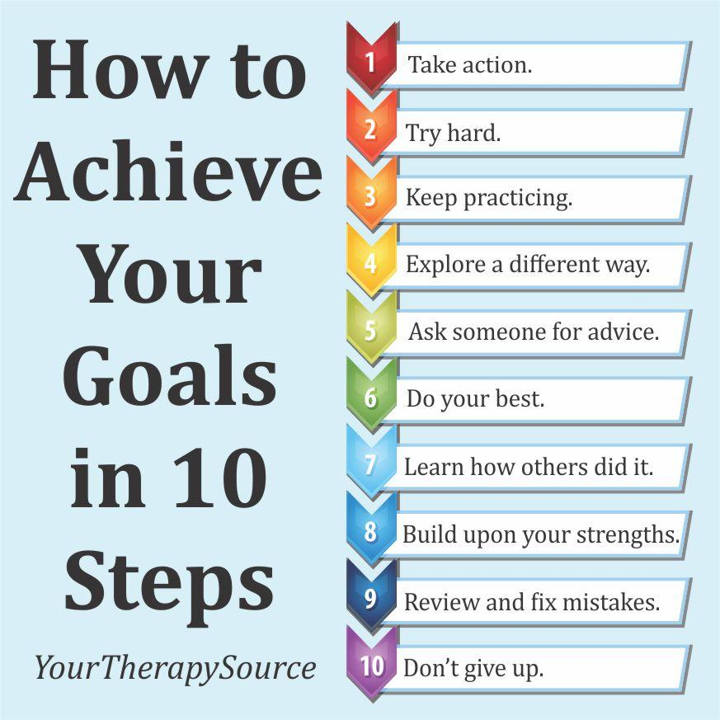

**Educational:** courses, programs, training, diplomas, mentors, jobs, networking, necessary skills and tools, internship, etc.

**Personal:** social, extra-curricular, health, wellness, relationships, travel, volunteer, clubs, international, etc.

**What is one short term goal (by the end of Grade 8) for your educational development?**

**What is one long term goal (by graduating high school) for your educational development?**

**What is one short term goal (by the end of Grade 8) for your personal development?**

**What is one long term goal (by graduating high school) for your personal development?**

**Pick one of your goals from above and turn it into a s.m.a.r.t. goal: (specific, measurable, attainable, relevant, time-bound)**

**Goal: By the end of Grade 8, I want to be able to know how to knit/sew/mend my own things as I please.**

**S:** (What do you want to accomplish? Who needs to be included? When do you want to do this? Why is this a goal?)

**M:** (How can you measure progress? How do you know if you successfully met your goal?)

**A:** (Do you have the skills required to achieve this goal? If not, can you obtain them? What is the motivation for this goal? Is the amount of effort required equal to what the goal will achieve?)

**R:** (Why am I setting this goal now? Does it connect to who I am as a person?)

**T:** (What’s the deadline? Is it realistic?