Careers 8
How to Activate your MyBlueprint Account
Assignment

All Delta School District students have had a MyBlueprint account created for them; however, each student needs to activate their account.

Please follow these instructions on how to activate your account:

A. Student accounts are created automatically overnight after a parent/guardian provides consent on Parent Connect. Parents can find the MyBlueprint consent form in the FORMS section of Parent Connect.
- Parents provide consent on Parent Connect. If this is completed proceed to #2
- Go to www.myBlueprint.ca/sd37
- Click School Account Log In

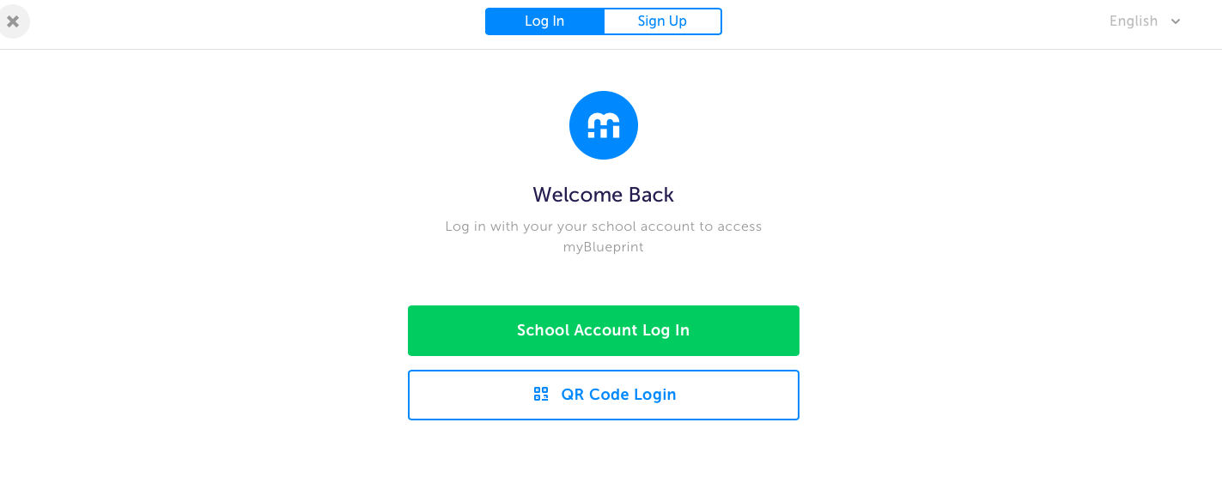
You will be redirected to the following page
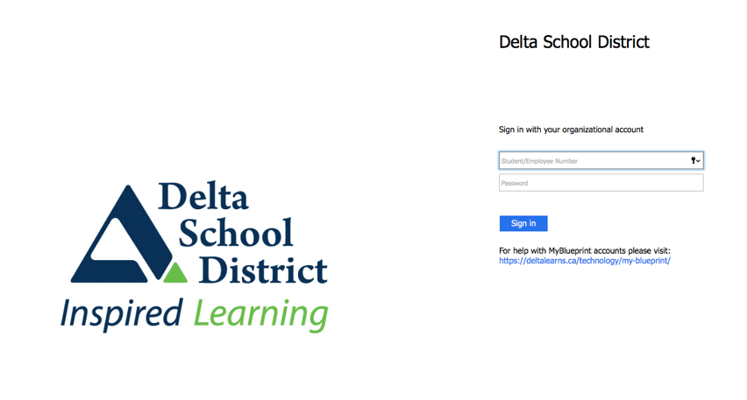

- Log in using student SD37 credentials (Delta student number and password from Student Connect) and confirm with birthdate
- Select the account type you want
- Follow the account creation process

B. Once your account has been activated, please logout and attempt to re-login in order to ensure you have access.

C. Complete this Google Form and hit submit
https://forms.gle/85Kicgz7jZ8sgd4x5

