Networking Assignment / LinkedIn Assignment

Watch the following video on Networking and answer the following questions:

https://study.com/articles/Networking:_How_Can_Networking_Help_with_Career_Planning.html

1. In your own words, describe what Networking is and how it can be beneficial?

2. What people are currently in your Network? Identify and list.

3. How can you increase your Network immediately?

4. Identify and list the type of individuals you should be reaching out to for Networking
Purposes in order to benefit your career options (name, title, company).

LinkedIn

LinkedIn is an employment oriented online service that operates via website and mobile apps. The platform is mainly used for professional networking, and allows job seekers to post their resume’s and employers to post jobs.

As you transition from Secondary School to Post-Secondary, to Employment and eventually to a Career, networking and connecting with like minded individuals is extremely important. This assignment asks you to take an initial step in networking by creating a LinkedIn account.

Follow these steps to create your LinkedIn account and complete this assignment.

1. Go to https://www.linkedin.com

2. Select “Join Now” in the top right-hand corner

3. Enter your email address and password; select “Agree and Join”

4. Enter First and Last Name; select “Continue”

5. Confirm profile information and verify is asked to do so

6. Input most recent job title or select student

7. Input information on where you are working or what institution you plan to attend for
Post-Secondary along with other important information requested; select confirm

8. Confirm your email by inputting the code sent to your email; select “Agree & Confirm”

9. Answer if you are looking for a new job question and continue

10. You can immediately begin to search for jobs following the prompts or you can begin to edit your profile

Congratulations, your Linkedin Profile has been created. Now you need to edit and
personalize your profile

1. Along the top bar of the screen, click on the circle with the shadow of a head (top right-hand side)

2. Select “View Profile”

3. Click “Add a Photo”; upload a picture that is good representation of who you are and who you want to be. Remember, potential connections and employers will see your profile picture.

4. Build Your Network ; click “Find Connections”
- a list is generated of potential people to connect with; this is where your networking begins
- browse the list of suggested connections; find people who you could connect with that could possibly help you get to where you want to go in life and in a career.

5. Click “connect” with 15-20 individuals. The goal is to have at least 10 people accept your connection. Think of the individuals in the field you want a career in, search for the post-secondary institution you may attend, search specific companies or businesses you would like to work for, etc.

6. In the top Search window; search Ryan Birt and click on my profile. Click the three dots to the right of the message tab and send me a connection request with the following personal message “Hi Mr. Birt, please accept my connection request”.
- this will help me know that you have successfully completed the assignment.

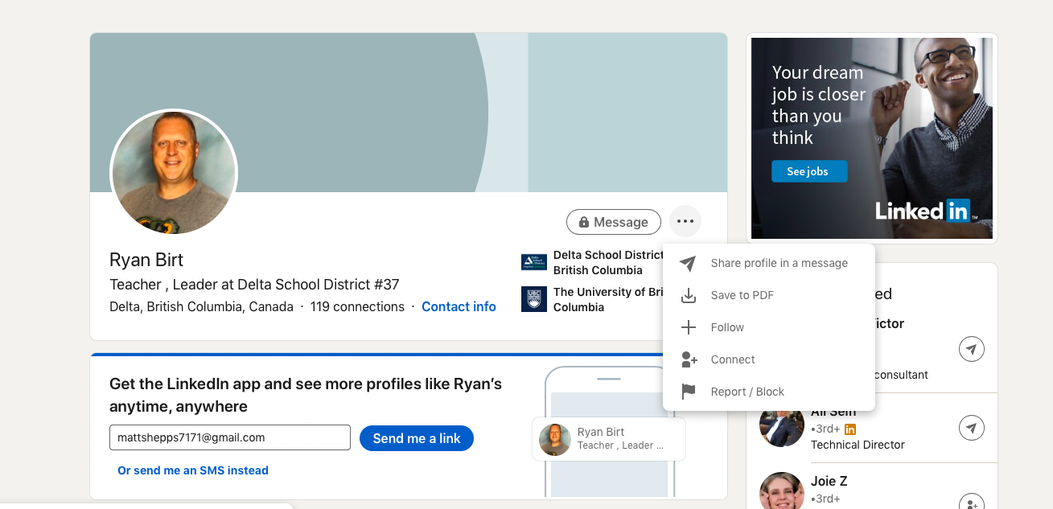

Once you have created your basic Linkedin profile, you can follow this link for tips on how to use and maximize the impact of your profile.

https://www.linkedin.com/help/linkedin/answer/112133/how-do-i-create-a-good-linkedin-profile-?lang=en

